ECE 385 Fall 2020

Final Proposal (Tetris)

Xiao Xichu, Li Mingzhi

TA: Yin Haocheng

* **Ideas and Overview**

We propose to design a Tetris for final project on the FPGA as a System-on-chip. The anticipated result of our game is to create a scenario that plenty of various shaped plates, which are made up by small squares, will descend from the top of the screen, and players can adjust the direction of the plates by pressing a certain key on the keyboard (like ‘w’). As long as the squares form a complete line or lines at the bottom of the screen, these complete bars then disappear to make room for the newly fallen blocks and the player is rewarded with points accumulated on the Hexdriver of FPGA board. The various shapes of squares will keep falling down, thus uneliminated blocks will pile up until they reach the top of the screen. Then, a “loss” figure will show up and the game is over. (The basic function is described here, but as you know, depending on the shape of the falling block, the function realization varies a lot, so we take the “Basic Rules” parts in ‘Baike’ as our finest requirement: https://baike.baidu.com/item/俄罗斯方块/535753?fr=aladdin)

Additionally, we will implement all steps using SystemVerilog essential components such as the System Bus, RAM, Keyboard and LED. In specific, we will store all the address allocation information and falling speed in Hardware parts and expect to display recorded points on the Hexdriver. Our design will also include a NIOS II CPU for the purposes of interfacing with the USB keyboard as in lab8 to make judgements about whether to fall or rotate. Therefore, our goal is to demonstrate our IIe SoC using the USB keyboard and VGA monitor.

* **Block Diagram**

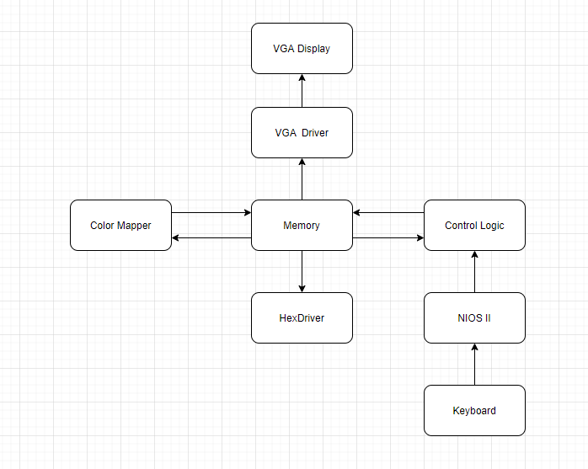

* **List of Features**

1. Baseline set of Features:

* Able to use NIOS II to control the keyboard to control whether the falling block to rotate
* Able to display scores on Hexdriver
* Able to eliminate a complete line or lines at the bottom of the screen.

1. Additional Features:

Willing to try additional functions but we hold a pessimistic view on it. We expect to add USB mouth or display scores on screen if possible.

* **Expected Difficulty**

Actually, Tetris is at the medium in the rough examples listed on lecture pptx. So, the baseline difficulty point is 5. For additional features, we expect to show the scores on the screen as long as the rest of our design works smoothly.

* **Proposed Timeline**

Week 1: (12.9) Discuss the proposal with TA, establish the possible needed platform designer and try to display squares on the screen.

Week 2: (12.16) Make squares falling down and as long as the bottom line is not filled, make them uneliminated. Then, rotate the falling squares.

Week3: (12.23) set the judgement conditions to make squares disappear to make rooms. Record the scores on FPGA Hexdriver.

Week4: (12.30) The final demo and check all the existing bugs.